SMART WATCH

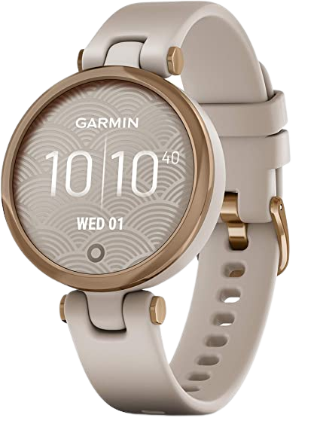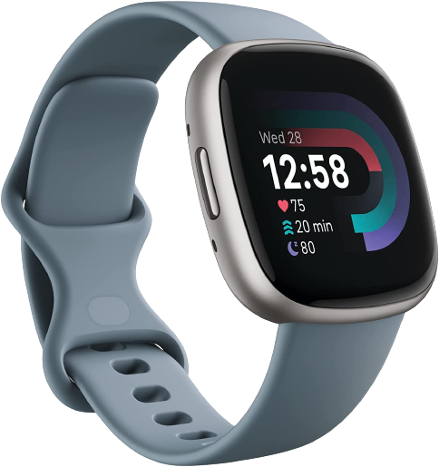

PHAL HIM – CLASS B

IN ENGLISH

Contents

1. Presentation of the products 2

A. Garmin lily 2

B. Fitbit versa 2

2. Which watch should you buy? 3

3. Let s talk to watch Serices 4





1. Presentation of the products
2. Garmin lily

* Small[1] stylish smartwatch complements your look with a unique decorative lens that reveals a bright touchscreen display with a tap. Supported Application: GPS, Contacts. Connectivity technology: GPS. Wireless comm standard:802_11_G
* Battery life: up to 5 days
* Understand your body by monitoring your respiration, Pulse Ox (this is not a medical device), energy levels, menstrual cycle, pregnancy, hydration, all-day stress, sleep (when paired to a compatible smartphone) and estimated heart rate
* connects to your compatible smartphone's GPS to accurately track outdoor walks, runs and more
* See how active you are throughout the day with step counting, calories burned, intensity minutes and more
* Choose from classic or sport designs with a variety of color, metal and band options - including leather and silicone
* so you can find the perfect piece to fit your look

1. Fitbit versa

*  Get inspired and stay accountable with Versa 4 + Premium - learn[2] when to work out or recover, see real-time stats during exercise and find new ways to keep your routine fresh and fun
* Built for better fitness results: Daily Readiness Score(1), built-in GPS and workout intensity map
* Tools to measure and improve sleep quality: personalized Sleep Profile(1), daily sleep stages & Sleep Score, smart wake alarm and do not disturb mode
* Maintain a healthy body and mind: daily Stress Management Score, reflection logging, SpO2(2), health metrics dashboard(3)
* Designed for fitness & beyond: on-wrist Bluetooth calls, texts and phone notifications(4)



1. Which watch should you buy?

* Small stylish smartwatch complements your look with a unique decorative lens that reveals a bright touchscreen display with a tap. Supported Application: GPS, Contacts. Connectivity technology: GPS. Wireless comm standard:802_11_G
* Battery life: up to 5 days
* Understand your body by monitoring your respiration, Pulse Ox (this is not a medical device), energy levels, menstrual cycle, pregnancy, hydration, all-day stress, sleep (when paired to a compatible smartphone) and estimated heart rate
* connects to your compatible smartphone's GPS to accurately track outdoor walks, runs and more
* See how active you are throughout the day with step counting, calories burned, intensity minutes and more
* Choose from classic or sport designs with a variety of color, metal and band options - including leather and silicone
* so you can find the perfect piece to fit your look

|  |  |  |
| --- | --- | --- |
|  | Garmin lily | Fitbit versa |
| Price | $198.88 | $159.95 |
| Sold By | jerimac LLC | Amazon.con |
| Color | Rose Goldand Light Tan | Waterfall Blue/Platinum |
| Item Dimensions | 5.51 x 0.2 x 1.36 inches | 1.57 x 0.43 x 1.57 inches |
| Item Weight | 0.85 ounces | 7.04 ounces |

1. Let s talk to watch Serices

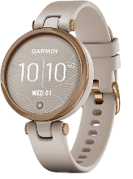



Smart watch​ is my best friend in my life

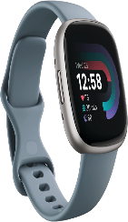

Why do you like to smart watch? Garmin lily

I chose smart watch because

Battery life: Up to 5 days. Discover your body by tracking your breathing, Pulse Ox, energy levels, menstrual cycle, pregnancy, hydration, stress throughout the day, sleep (when paired with a compatible smartphone), and estimated heart rate.

I chose smart watch Fitbit versa because Tools to measure and improve sleep quality: personalized Sleep Profile (1), daily sleep stages & Sleep Score, smart wake alarm and do not disturb mode

Why do you like to smart watch? Fitbit versa?

Fitbit versa more special

1. Garmin Lily™, Small GPS Smartwatch with Touchscreen and Patterned Lens, Rose Gold and Light Tan
2. Fitbit Versa 4 Fitness Smartwatch with Daily Readiness, GPS, 24/7 Heart Rate, 40+ Exercise Modes, Sleep Tracking and more, Waterfall Blue/Platinum, One Size (S & L Bands Included)